Q1.
What will happen when you attempt to compile and run the following code?
1. public class Test extends Thread{
2. public static void main(String argv[]){
3. Test t = new Test();
4. t.run();
5. t.start();
6. }
7. public void run(){
8. System.out.println("run-test");
9. }
10.}

Options are
A.run-test run-test
B.run-test
C.Compilation fails due to an error on line 4
D.Compilation fails due to an error on line 7

Q2.
What is the output for the below code ?
class A implements Runnable{
public void run(){
System.out.println("run-a");
}
}
1. public class Test {
2. public static void main(String... args) {
3. A a = new A();
4. Thread t = new Thread(a);
5. t.start();
6. t.start();
7. }
8.}

Options are
A.run-a
B.run-a run-a
C.Compilation fails with an error at line 6
D.Compilation succeed but Runtime Exception

Q3.
What is the output for the below code?

import java.util.Iterator;
import java.util.TreeSet;
public class Test {
public static void main(String... args) {
TreeSet s1 = new TreeSet();
s1.add("one");
s1.add("two");
s1.add("three");
s1.add("one");
Iterator it = s1.iterator();
while (it.hasNext() ) {
System.out.print( it.next() + " " );
}
}
}

Options are

.one three twoA
B.Runtime Exception
C.one three two one
D.one two three

Q4.
What will happen when you attempt to compile and run the following code ?
class A implements Runnable{
public void run(){
System.out.println("run-A");
}
}

1. public class Test {
2. public static void main(String argv[]){
3. A a = new A();
4. Thread t = new Thread(a);
5. System.out.println(t.isAlive());
6. t.start();
7. System.out.println(t.isAlive());
8. }
9. }

Options are
A.false run-A true
B.false run-A false
C.true run-A true
D.Compilation fails due to an error on line 7

Q5.

Thread priority in Java is?
- Integer
- Float
- double
- long

Q6.
What will be output of given code -
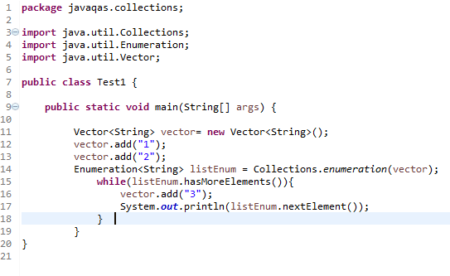
a. will execute without any exception
b. (None of these)
c. compilation error
d. Throw ConcurrentModificationException

Q7.
What will be output of following code -
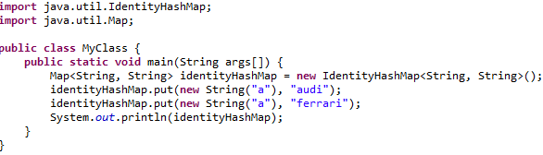
a. {a=ferrari}
b. {a=audi, a=ferrari}
c. Runtime Exception
d. {a=audi}

Q8.

What will be output of following code -
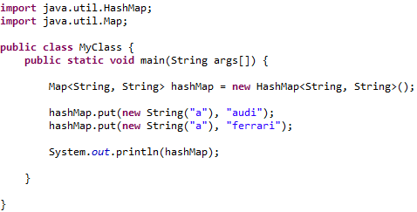
a. {a=ferrari}
b. {a=audi, a=ferrari}
c. {a=audi}
d. null

Q9.
What will be output of following code -
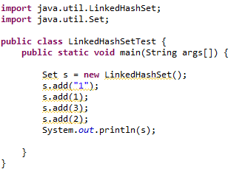
a. [1, 1, 2, 3]
b. [1, 2, 2, 3]
c. [1, 1, 3, 2]
d. [1, 2, 3]

Q10 .
How can Thread go from waiting to runnable state?
a. notify/notifAll
b. When sleep time is up
c. Using resume() method when thread was suspended
d. All

